From:

I Started Fact-Checking Trump — And Realized It’s Not Easy

It’s difficult to check someone’s facts if they aren’t actually providing any

Ben Chapman
Jan 13, 2019
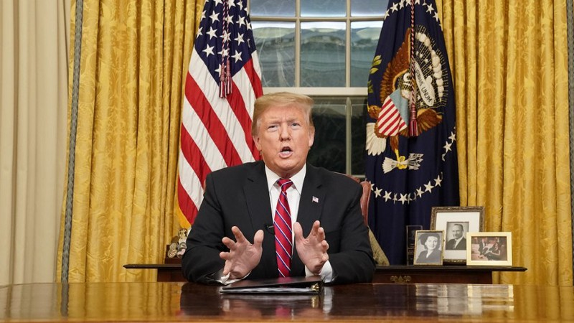
Donald Trump in his infamous immigration address
When I say that our President isn’t providing any facts, I don’t mean that he’s a liar — though he is. Only 14% of his statements were categorized as mostly true or true by Politifact, and the Washington Post reports that he has made almost 8,000 false or misleading claims since taking office. When I say that he isn’t providing facts, what I mean is, he’s giving conclusions without evidence. This is to say, he’s not lying, he’s just wrong. But you can’t lie about being wrong.
The press has a mandate to provide the public with the truth, so when President Trump’s highly anticipated Oval Office address was scheduled to air, smart audience members knew that the real story would be the fact-checks of the next day. The problem was, those fact checks weren’t so clear.
The NY Times rated two claims as “false,” one as “misleading,” and six as “this needs context.” Not exactly a stirring argument for truth. I checked to see whether this vague reality is characteristic of Trump, and found that
- [for Trump] only 19% of the statements checked by Politifact were either indisputably true or false (source).
- For Hillary Clinton, that number is 26% (source),
- for Bernie Sanders, it’s 25% (source), and
- for Barack Obama, it’s 21% (source).
While the difference isn’t stark, it is certainly noticeable that verifying President Trump’s statements beyond reasonable doubt is more difficult than with previous Presidential-level politicians.
So why is this? I found out when I satirically changed my Twitter account to a fact checking account. It started out innocent.
But then I actually fact checked a real claim by Donald Trump.
And then I made a habit of it. Through the process of trying to fact check his other claims, I learned why they NY Times’ diagnoses of Trump’s claims lacked conviction.
It’s because the Trumpian flow of logic doesn’t require evidence or a basis of fact, and if the President doesn’t assert any basis of fact, then there is no fact to check — thus, the muddied water.
[Someone more supportive of Trump might argue that
- There are simple assertions of fact (The melting point of water at atmospheric pressure is ….) and
- there are simple statements of value (The song I like most at the start of a football game is …) and
- there are "political" assertions that are a summarization of facts, values, and a plan of action. (We need to control immigration better. We don't need to sequester CO2.)
Isn't that most of it?
Could Trump simply be too smart to include in each assertion of his summary judgement (speech, tweet, …) based on a lifetime of experience?
Here is the path of logic most of us are familiar with and would at least like to think we use ourselves.
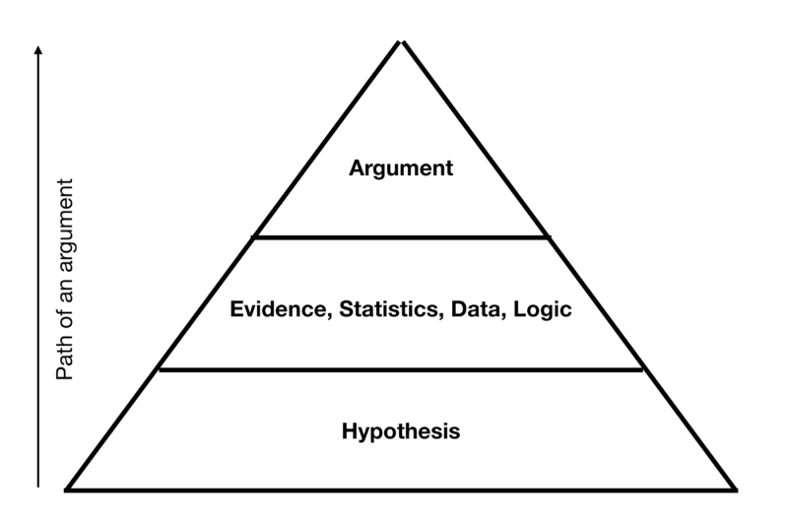
We have an idea, then we develop evidence and facts around it, and then we formulate an argument based on that evidence. Fact checkers can easily pick out the facts and check them.
If Al Gore claims that data shows that Arctic sea ice is melting at a faster than normal rate and therefore climate change is a threat, then fact checkers can easily follow up with experts and research papers to check whether Arctic sea ice is actually melting.
But when our current President claims that a border wall will prevent illegal immigration and will make our nation safer, then he hasn’t truly asserted any clearly verifiable fact — he has skipped straight to the argument. Theoretically, a journalist could look into data on the effectiveness of ladders, pole vaulting, tunnel digging, and human catapults in regards to wall traversions, and then make a case as to whether a wall will actually prevent border crossings. An even smarter journalist might look at data about how undocumented immigrants find their way into the U.S. and make conclusions about whether a wall would even affect a substantial proportion of potential migrants. But neither of these fact checkers will be able to clearly confirm whether or not the President is actually “telling the truth,” simply because of the vague sweepingness of the President’s claim and the lack of checkable evidence.
Below is a graphic of President Trump’s “logic” flow.
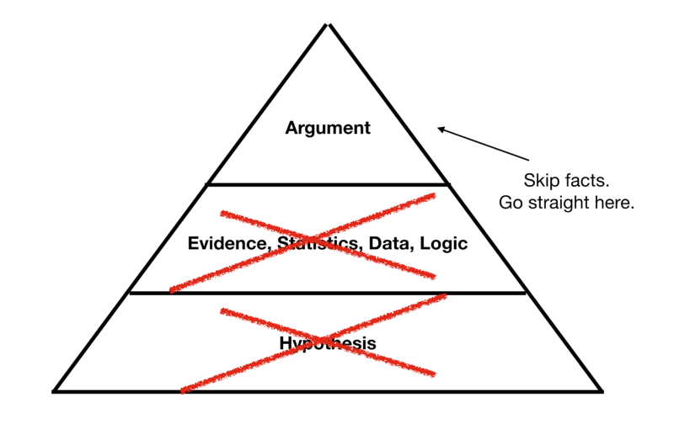
He leaves the facts and evidential claims out of his argument construction process, and skips straight to the claim. It makes his speeches exciting, but not necessarily beneficial to those who seek the truth.
When the President makes an inaccurate claim, he’s not lying, he’s just wrong. [Or right. (And remember, when we elected him, we knew that a businessperson faced a steeper learning curve than a different candidate who' never held a private industry job!) Let's vote on it!]
Think I’m wrong? Fact check me. Go to the President’s Twitter and take a tweet that makes an argument. Or find a speech. See if you can find evidence that he clearly connects to a claim. Fact check him.
Let me know how it goes.
-Ben Chapman
Ben Chapman is a reporter and commentator in Illinois. He is a student in Food Science and Human Nutrition and ran for his local County Board in 2018. You can learn more about him and stay updated on his commentaries at his Facebook Page and his Twitter
189 claps
2
• Follow


Ben Chapman

